HEALTH AND SAFETY REPORTING FORM

Section A - For reporting hazards, accidents , and incidents
Report type (tick all that apply):
☐ Accident ☐ Incident ☐ Hazard observed ☐ Property damage ☐ Behavioural Concern
☐ Injury ☐ Medical event ☐ Illness ☐ Discomfort ☐ Other (list):
Date of occurrence or observation: Time:
Exact location of occurrence or observation:
Brief description of what occurred or was observed:

List any harm that has or could potentially occur:

List the names and phone numbers of anyone directly harmed or affected:

List the names and phone numbers of any witnesses:

Tick all the factors present that influenced the occurrence or observation
 | ☐ Venue factor (incl. fixtures or fittings)  ☐ Work equipment  ☐ Safety equipment / PPE  ☐ Machinery  ☐ Tools  ☐ Heights  ☐ Chemical/ hazardous material  ☐ Repeated movements  ☐ Work position / posture  ☐ Environmental factors (e.g. wind, rain)  ☐ Temperature | ☐ Tiredness  ☐ Inexperience with task or equipment  ☐ Load, weight  ☐ Slipping or tripping  ☐ Low light / reduced visibility  ☐ Noise / difficulty hearing  ☐ Other worker(s) / work teams  ☐ Member of the public  ☐ Alcohol / drugs / medication  ☐ Others (list):
What has already been done to fix things or secure the area to prevent (further) harm occurring?

Have you got any suggestions?

Person completing this form:
Name: Mobile number:

Section B – Injured person details (complete when someone has been harmed)
Name: Date of birth:
Address: Phone number:
STATUS (TICK):
☐ Trainer ☐ Student ☐ Contractor ☐ Visitor /Audience ☐ Public ☐ Performer ☐ Other (state):
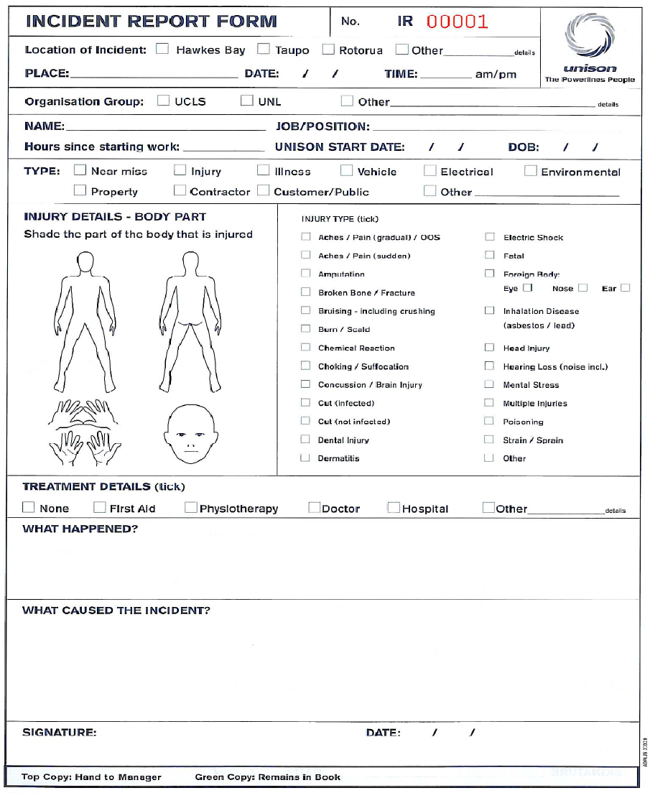 | INJURY TYPE (tick all that apply)
 | ☐ Aches, pains (gradual) /OOS  ☐ Aches, pains (sudden)  ☐ Amputation  ☐ Broken bones /fracture  ☐ Bruising &/or crushing  ☐ Burn / scald  ☐ Choking / suffocation  ☐ Concussion / brain injury  ☐ Cut  ☐ Death  ☐ Dental injury  ☐ Electric shock | ☐ Foreign body  ☐ Inhalation disease  ☐ Head injury  ☐ Hearing loss  ☐ Mental stress  ☐ Multiple injuries  ☐ Poisoning  ☐ Skin reaction  ☐ Sprain / strain  ☐ Other
 | DESCRIBE THE BODY PART(S) AFFECTED:
SEVERITY: ☐ Severe pain ☐ Pain ☐ Mild pain ☐ Discomfort
TREATMENT: ☐ Nil ☐ First Aid ☐ Doctor /Medical ☐ Hospital

Section C – Completed by the relevant Manager
Who has been notified of the occurrence or observation?
From Company (list people):
From the venue or contractors (list people):
Others (list people):

Has WorkSafe NZ been notified? ☐Not required ☐NO ☐YES Date: Ref #:
What remedial actions have been taken to prevent (further) harm?

What follow up actions have occurred with those affected:

Which Health & Safety Committee(s) have reviewed this report?

